**Laporan Pertemuan 4 Teknik Pemrograman**

**Praktik**



**Disusun oleh :**

**Nesta Rizkia Saputra (231524060)**

**Kelas :**

**D4 – 1B Teknik Informatika**

**Tahun Ajaran 2023 – 2024**

# EXERCISE 1

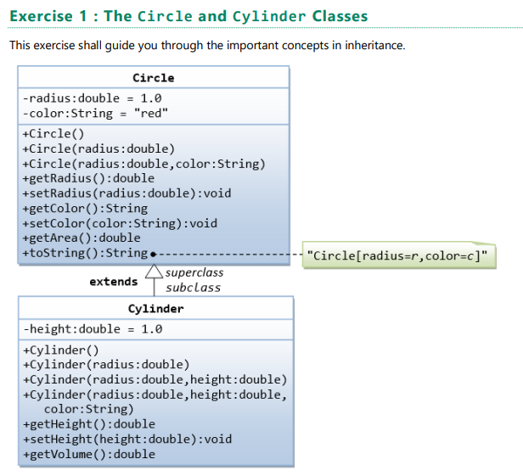

Circle dan Cylinder merupakan sebuah class dengan properties yang ada dibawahnya. Dimana terdapat Attributes yaitu yang terdapat dibawah dari nama class. Lalu yang ada dibawahnya lagi adalah method – method yang terdapat pada class nya.

/**

* The Circle class models a circle with a radius and color.

*/

public class Circle

{

    // Save as "Circle.java"

    // private instance variable, not accessible from outside this class

    private double radius;

    private String color;

    // Constructor 3rd task 1.1

    public Circle(double r,String c)

    {

        this.radius = r;

        this.color = c;

    }

    // Constructors (overloaded)

    /** Constructs a Circle instance with default value for radius and color */

    public Circle()

    { // 1st (default) constructor

        radius = 1.0;

        color = "red";

    }

    /** Constructs a Circle instance with the given radius and default color */

    public Circle(double r)

    { // 2nd constructor

        radius = r;

        color = "red";

    }

    /** Returns the radius */

    public double getRadius()

    {

        return radius;

    }

    /** Returns the area of this Circle instance */

    public double getArea()

    {

        return radius*radius*Math.PI;

    }

    /** Return a self-descriptive string of this instance in the form of

    Circle[radius=?,color=?] */

    public String toString()

    {

        return "Circle[radius=" + radius + " color=" + color + "]";

    }

    // task 1.1

    public String getColor()

    {

        return color;

    }

    // task 1.1

    public void setColor(String color)

    {

        this.color = color;

    }

}

public class Cylinder extends Circle

{  //Save as "Cylinder.java"

    private double height; // private variable

    // Constructor with default color, radius and height

    public Cylinder()

    {

        super(); // call superclass no-arg constructor Circle()

        height = 1.0;

    }

    // Constructor with default radius, color but given height

    public Cylinder(double height)

    {

        super(); // call superclass no-arg constructor Circle()

        this.height = height;

    }

    // Constructor with default color, but given radius, height

    public Cylinder(double radius, double height)

    {

        super(radius); // call superclass constructor Circle(r)

        this.height = height;

    }

    // A public method for retrieving the height

    public double getHeight()

    {

        return height;

    }

    // A public method for computing the volume of cylinder

    // use superclass method getArea() to get the base area

    public double getVolume()

    {

        return super.getArea()*height;

    }

    // task 1.2

    @Override

    public double getArea()

    {

        return 2*Math.PI*getRadius()*height+2*getVolume();

    }

    // task 1.3

    @Override

    public String toString()

    { // in Cylinder class

        return "Cylinder: subclass of " + super.toString() + " height=" + height; // use Circle's toString()

    }

}

 public class TestCylinder

    { // save as "TestCylinder.java"

    public static void main (String[] args)

    {

    // Declare and allocate a new instance of cylinder

    // with default color, radius, and height

    Cylinder c1 = new Cylinder();

    System.out.println("Cylinder:"

    + " radius=" + c1.getRadius()

    + " height=" + c1.getHeight()

    + " base area=" + c1.getArea()

    + " volume=" + c1.getVolume()

    + " " + c1.toString()); // task 1.3

    // Declare and allocate a new instance of cylinder

    // specifying height, with default color and radius

    Cylinder c2 = new Cylinder(10.0);

    System.out.println("Cylinder:"

    + " radius=" + c2.getRadius()

    + " height=" + c2.getHeight()

    + " base area=" + c2.getArea()

    + " volume=" + c2.getVolume()

    + " " + c2.toString()); //task 1.3

    // Declare and allocate a new instance of cylinder

    // specifying radius and height, with default color

    Cylinder c3 = new Cylinder(2.0, 10.0);

    System.out.println("Cylinder:"

    + " radius=" + c3.getRadius()

    + " height=" + c3.getHeight()

    + " base area=" + c3.getArea()

    + " volume=" + c3.getVolume()

    + " " + c3.toString()); // task 1.3

    }

}

## Task 1.1

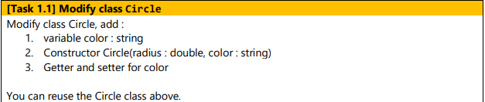

### Penyelesaian

1. 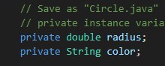
2. 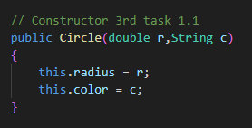
3. 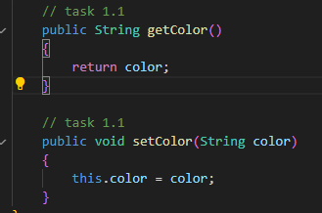

### Output

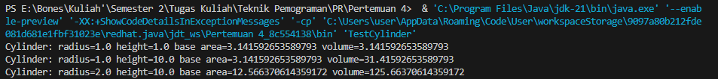

## Task 1.2

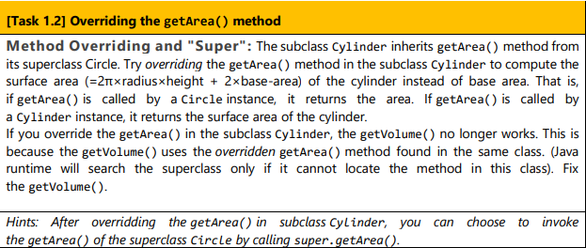

### Penyelesaian

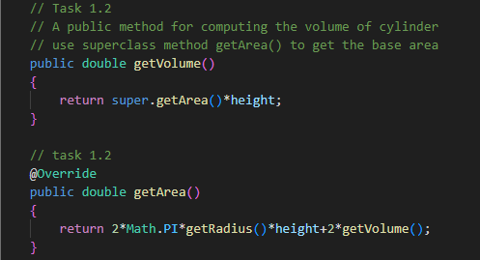

### Output

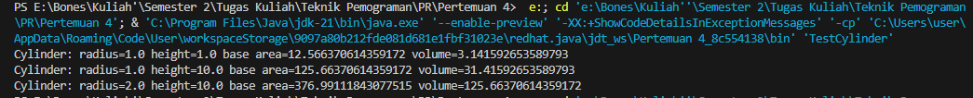

## Task 1.3

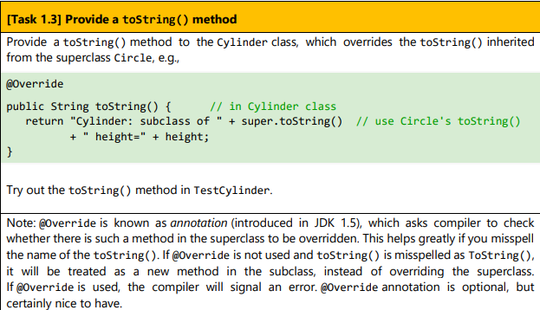

### Penyelesaian

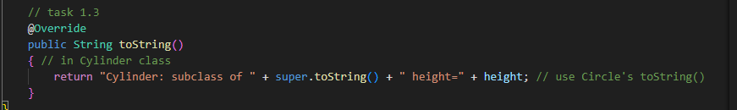

### Output

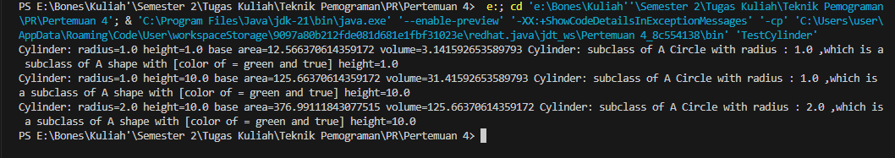

# Exercise 2

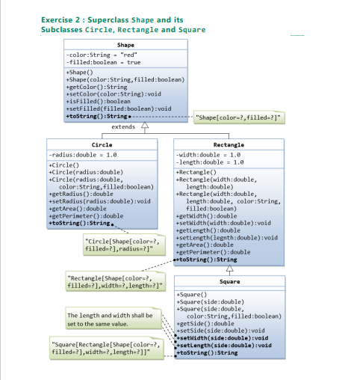

Gambar diatas merupakan request untuk class juga attributes dari masing – masing class dan method – method nya.

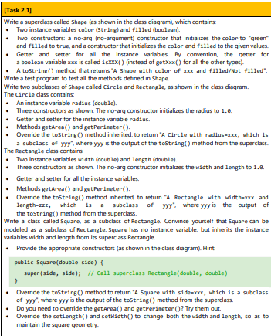

## Task 2.1

### SuperClass Shape

public class Shape

{

    // private instance variable

    private String color;

    private Boolean filled;

    // 1st Constructs a shape instance with default value for color and filled

    public Shape()

    {

        color = "green";

        filled = true;

    }

    // 2nd Construct a shape instance with given values for color and filled

    public Shape(String color,boolean filled)

    {

        this.color = color;

        this.filled = filled;

    }

    public String getColor()

    {

        return color;

    }

    public void setColor()

    {

        this.color = color;

    }

    public boolean isFilled()

    {

        return filled;

    }

    public void setFilled()

    {

        this.filled = filled;

    }

    public String toString()

    {

        return ("A shape with [color of = " + color + " and " + filled + "]");

    }

}

### Class Circle (subclass superclass Shape)

public class Circle extends Shape

{

    private double radius;

    public Circle ()

    {

        radius = 1.0;

    }

    public Circle (double radius)

    {

        this.radius = radius;

    }

    public Circle (double radius,String color,boolean filled)

    {

        super(color,filled);

        this.radius = radius;

    }

    public double getRadius()

    {

        return radius;

    }

    public void setRadius()

    {

        this.radius = radius;

    }

    public double getArea()

    {

        return radius*radius*Math.PI;

    }

    public double getPerimeter()

    {

        return 2*Math.PI*getRadius();

    }

    @Override

    public String toString()

    {

        return "A Circle with radius : " + getRadius() + " ,which is a subclass of " + super.toString();

    }

}

### Class Rectangle (Subclass class Shape dan SuperClass)

public class Rectangle

{

    private double width;

    private double length;

    public Rectangle()

    {

        width = 1.0;

        length = 1.0;

    }

    public Rectangle(double width, double length)

    {

        this.width = width;

        this.length = length;

    }

    public Rectangle(double width, double length, String color, boolean filled)

    {

        super();

        this.width = width;

        this.length = length;

    }

    public double getWidth()

    {

        return width;

    }

    public void setWidth(double width) {

        this.width = width;

    }

    public double getLength()

    {

        return length;

    }

    public void setLength(double length)

    {

        this.length = length;

    }

    public double getArea()

    {

        return getLength()*getWidth();

    }

    public double getPerimeter()

    {

        return 2*getLength()+getWidth();

    }

    @Override

    public String toString() {

        return "a Rectangle with width : " + getWidth() + "and length : " + getLength() + " ,which is a subclass of " + super.toString();

    }

}

### Class Square (Subclass class Rectangle)

class Square extends Rectangle

{

    public Square()

    {

     super();

    }

    public Square(double side)

    {

        super(side,side); // call superclass Rectangle (double,double)

    }

    public Square (double side, String color, boolean filled)

    {

        super(side,side,color,filled);

    }

    public double  getSide()

    {

        return super.getLength();

    }

    public void setSide(double side)

    {

        super.getLength();

    }

    @Override

    public void setLength(double side)

    {

        getSide();

    }

    @Override

    public void setWidth(double side)

    {

        getSide();

    }

    @Override

    public String toString()

    {

        return "A Square with side : " + getSide() + " ,which is a subclass of " + super.toString();

    }

    @Override

    public double getArea()

    {

        return getSide()*getSide();

    }

    @Override

    public double getPerimeter()

    {

        return 4*getSide();

    }

}

### Class TestShape (Main)

public class TestShape

{

    public static void main(String[] args)

    {

        //Declare and allocate a new instance of shape with default color and filled

        Shape s1 = new Shape();     // it's identifier for the first output

        System.out.println(s1.toString());

        // Declare and allocate a new instance of shape with given values color and filled

        Shape s2 = new Shape("white",true); // it's identifier for the second output

        System.out.println(s2.toString() + "\n" );

        //Declare and allocate a new instance of Circle with default

        Circle c1 = new Circle();     // it's identifier for the first output

        System.out.println(c1.toString());

        // Declare and allocate a new instance of Circle with given values

        Circle c2 = new Circle(10.0); // it's identifier for the second output

        System.out.println(c2.toString());

        // Declare and allocate a new instance of Circle with given values color and filled

        Circle c3 = new Circle(100.0,"White", true); // it's identifier for the Third output

        System.out.println(c3.toString() + "\n" );

        //Declare and allocate a new instance of Rectangle with default

        Rectangle R1 = new Rectangle();     // it's identifier for the first output

        System.out.println(R1.toString());

        // Declare and allocate a new instance of Rectangle with given values

        Rectangle R2 = new Rectangle(10.0,15.0); // it's identifier for the second output

        System.out.println(R2.toString());

        // Declare and allocate a new instance of Rectangle with given values color and filled

        Rectangle R3 = new Rectangle(25.0,15.0,"black", true); // it's identifier for the third output

        System.out.println(R3.toString() + "\n" );

        //Declare and allocate a new instance of Square with default

        Square Sq1 = new Square();     // it's identifier for the first output

        System.out.println(Sq1.toString());

        // Declare and allocate a new instance of Square with given values

        Square Sq2 = new Square(25.0); // it's identifier for the second output

        System.out.println(Sq2.toString());

        // Declare and allocate a new instance of Square with given values color and filled

        Square Sq3 = new Square(30.0,"White", true); // it's identifier for the third output

        System.out.println(Sq3.toString() + "\n" );

    }

}

### OUTPUT

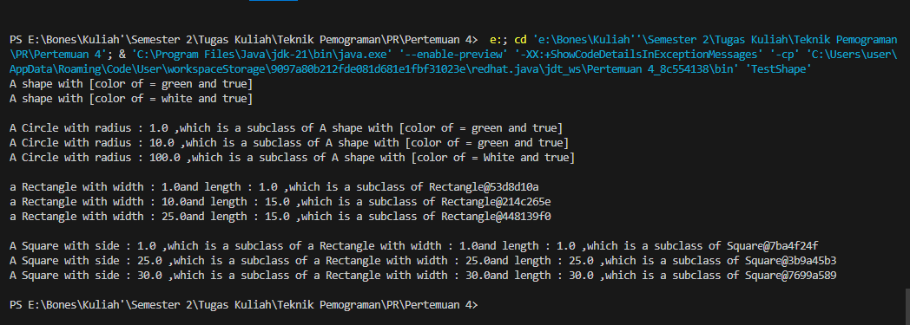

# Exercise 3

## Task 3.1

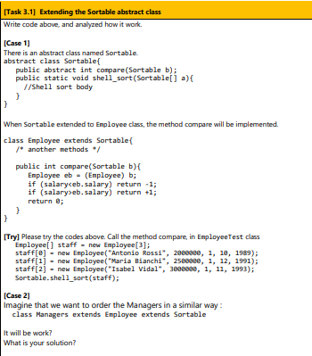

### Superclass Sortable

abstract class Sortable

{

    public abstract int compare(Sortable b);

    public static void shell_sort(Sortable[] a)

    {

        int n = a.length;

        // Membuat suatu nilai sebagai jarak lalu decrement

        for (int gap = n/2; gap > 0; gap = gap / 2)

        {

            for (int i = gap; i < n; i++)

            {

                // Menyimpan nilai yang akan di sorted pada temp

                Sortable temp = a[i];

                // Mencari posisi untuk temporary

                int j;

                for (j = i; j >= gap && a[j - gap].compare(temp) > 0; j -= gap)

                {

                    a[j] = a[j - gap];

                }

                // Meyimpan temporary pada tempat aslinya

                a[j] = temp;

            }

        }

    }

}

### Subclass dan Superclass Employee

class Employee extends Sortable

{

    private String name;

    private double salary;

    private int hireday;

    private int hiremonth;

    private int hireyear;

    public Employee(String n, double s, int day, int month, int year)

    {

        name = n;

        salary = s;

        hireday = day;

        hiremonth = month;

        hireyear = year;

    }

    public void print()

    {

        System.out.println(name + " " + salary + " "+ getHireday()+ " " + getHiremonth() + " " + hireYear());

    }

    public void raiseSalary(double byPercent)

    {

        salary *= 1 + byPercent / 100;

    }

    public int hireYear()

    {

        return hireyear;

    }

    public int getHireday() {

        return hireday;

    }

    public int getHiremonth() {

        return hiremonth;

    }

    /* another methods */

    public int compare(Sortable b)

    {

        Employee eb = (Employee) b;

        if (salary<eb.salary) return -1;

        if (salary>eb.salary) return +1;

        return 0;

        }

}

### Class EmployeeTest(Main for Employee)

public class EmployeeTest{

    public static void main (String[] args)

    {

        Employee[] staff = new Employee[3];

        staff[0] = new Employee("Antonio Rossi", 2000000, 1, 10, 1989);

        staff[1] = new Employee("Maria Bianchi", 2500000, 1, 12, 1991);

        staff[2] = new Employee("Isabel Vidal", 3000000, 1, 11, 1993);

        Sortable.shell_sort(staff);

        int i;

        for (i = 0; i < 3; i++) staff[i].raiseSalary(5);

        for (i = 0; i < 3; i++) staff[i].print();

    }

}

#### Output

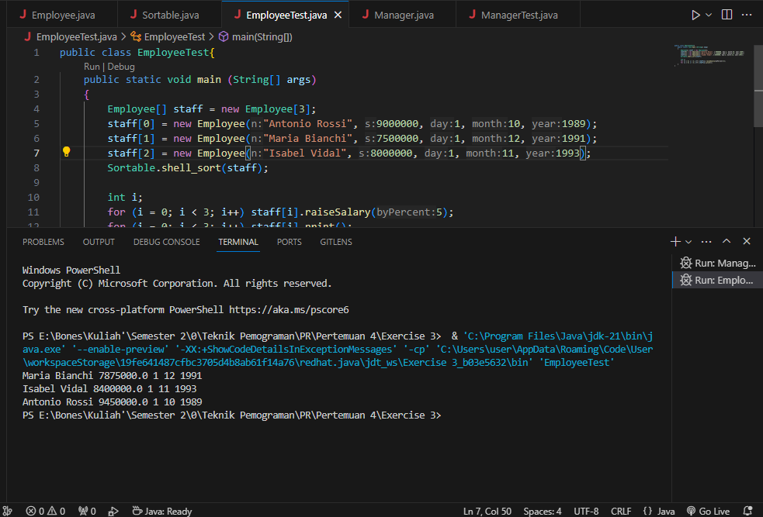

### Subclass Manager

import java.util.Calendar;

import java.util.GregorianCalendar;

class Manager extends Employee

{

    private String secretaryName;

    public Manager (String n, double s, int d, int m, int y)

    {

        super(n, s, d, m, y);

        secretaryName = "";

    }

    public void raiseSalary(double byPercent)

    {

        // add 1/2% bonus for every year of service

        GregorianCalendar todaysDate = new GregorianCalendar();

        int currentYear = todaysDate.get(Calendar.YEAR);

        double bonus = 0.5 * (currentYear - hireYear());

        super.raiseSalary(byPercent + bonus);

    }

    public String getSecretaryName()

    {

        return secretaryName;

    }

}

### Class TestManager(Manager Main)

public class ManagerTest

{

    public static void main (String[] args)

    {

        Employee[] staff = new Employee[3];

        staff[0] = new Employee("Antonio Rossi", 5000000, 1, 10, 1989);

        staff[1] = new Manager("Maria Bianchi", 4500000, 1, 12, 1991);

        staff[2] = new Employee("Isabel Vidal", 3000000, 1, 11, 1993);

        Sortable.shell_sort(staff);

        int i;

        for (i = 0; i < 3; i++) staff[i].raiseSalary(5);

        for (i = 0; i < 3; i++) staff[i].print();

    }

}

#### Output

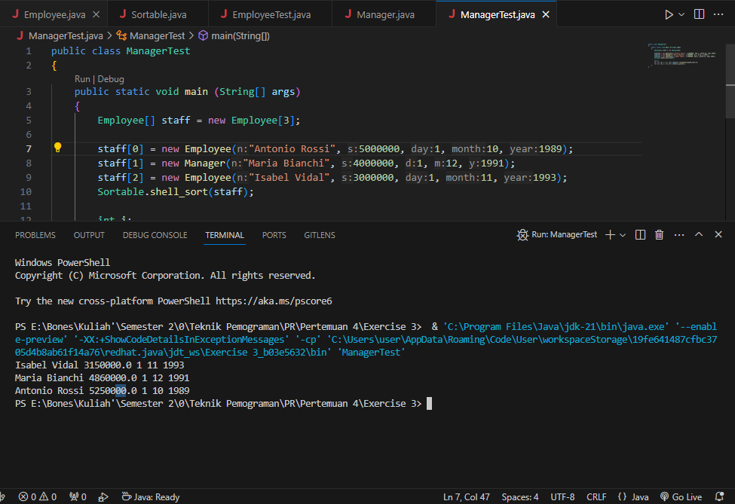

## Lesson Learn

1. Shell sort ini mirip dengan metode insertion sort namun bedanya pada Shell Sort kita mengambil nilai tengah dari suatu array terlebih dahulu, lalu melakukan insertion sort pada tiap sublist.
2. Pada perintah case 2 yang saya tahu seharusnya class Manager tidak bisa men extend class Employee namun pada saat saya coba, Class Manager masih bisa menggunakan method shell_sort.
3. Saya masih bingung akan tugas execise 3, mulai dari bagaimana seharusnya output atau program berjalan. Saya juga bingung pada saat hasil dari gaji seseorang yang sudah diberi bonus lebih dari yang lain, namun pada insert data pada code masih lebih kecil dari yang lain. Maka dia tetap berada diatas staff lain

Contoh :

